Lab 3: Determining the value of an Equilibrium constant
Purpose:
Using a titration, to experimentally determine the ksp of calcium hydroxide.

Procedure:
- Prepare an equilibrium mixture of calcium hydroxide by adding solid to distilled water, allow mixture to settle.
- Remove 10 mL of the ions mixture being careful not to disturb the solid and transfer into an Erlenmeyer flask, repeat for trials 2 and 3.
- Add 1-2 drops of phenolphthalein
- Using the 0.1M hydrochloric acid, titrate the ions mixture until the pink colour disappears.
- Record the volume of acid required to titrate and repeat for trials 2 and 3.

Calculations:
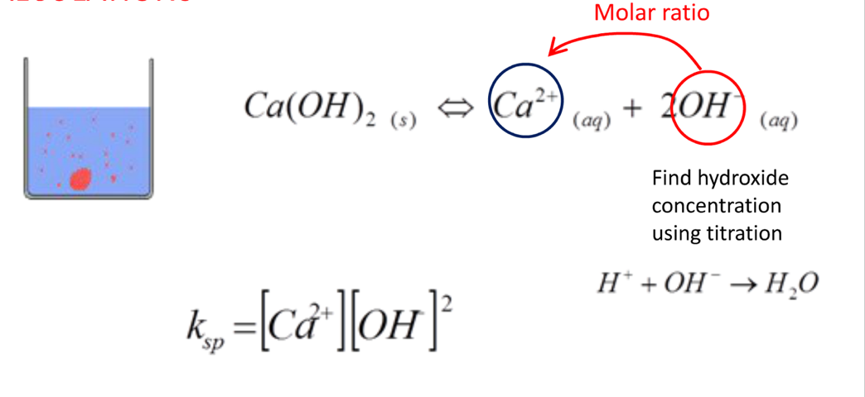
Find hydroxide concentration using titration

Link: https://www.youtube.com/watch?v=0N174A4Hhcs

Data Table:
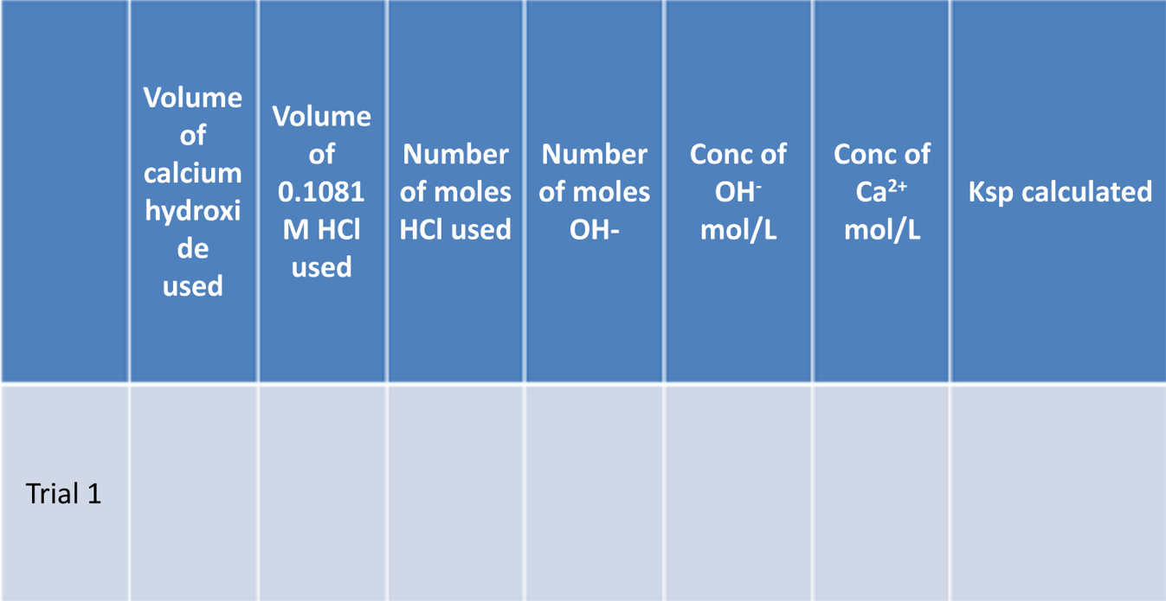
Requirements:

- Completed data tables
- Sample calculations for finding ksp of Calcium hydroxide experimentally
- The accepted value for the ksp of calcium hydroxide is 5 x 10 ⁻⁶, calculate the percent difference between the accepted value and your experimental value.
- Identify sources of error and uncertainty in the experimental design and provide some suggestions for improvement
- Conclusion?

